40.27: The ground state energy of a simple harmonic oscillator is, with 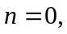
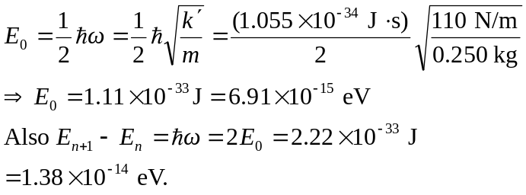
Such tiny energies are unimportant for the motion of the block so quantum effects are not important.

